

**Proposal and Quotation for Digital Marketing Services**

<https://www>.veloxn.com

**Introduction –**

Thank You for showing interest in Veloxn Private Limited for Digital Marketing services requirement.

**Service Cost -**

The table below details the cost associated with this service.

|  |  |  |  |
| --- | --- | --- | --- |
| **Name** | **Unit Price** | **Month** | **Subtotal** |
| Managing and posting at Social Accounts -   1. Facebook -1 Post Daily 2. Instagram -1 Post Daily 3. LinkedIn -1 Post Daily 4. Twitter (x) -1 Post Daily 5. YouTube -1 Post Daily 6. Run Google, Facebook, Instagram and Linked in Ads (Max budget 1 Lac/Month)   Creative work   1. Photo Editing (@ Rs 500 but normal template based or AI generated will be free) 2. Video Editing (@ Rs 2500 but normal template based or AI generated will be free)   Create/Update GMB Account and 10 Review Monthly  Other postings   1. Bulk Whatsapp messages(8 paisa MOQ 1 Lac) 2. Bulk Email (8 paisa MOQ 1 Lac) 3. Run Google/Facebook Ads(Ad run fee is included) 4. Bulk Voice call Email (17 paisa MOQ 1 Lac) | ₹10,000 | 1 | ₹10,000 |
|  |  |  |  |
| **SUBTOTAL** |  |  | ₹10,000 |
| GST |  |  | ₹1,800 |
| **TOTAL Including GST** |  |  | ₹11,800 |

Payment required is

**Note\*** - Offer Valid for 7 days only/-

**Bank Details**:

**VELOXN PRIVATE LIMITED**

AC Number – 259958439076

IFSC Code – INDB0000702

Bank Name – Indusind Bank

UPI ID - veloxnservices@okicici

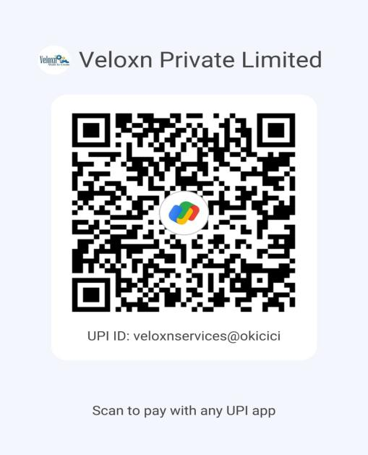

**COMPANY:**

Veloxn Private Limited

Iconic Tower C, Corenthum, Sector-62, Noida, UP - 201301, India www.veloxn.com

sales@veloxn.com

91-7292001010

GST - 06AAICV7138B1ZE